

Ripon Grammar School

21 April 2023

Dear Parents

Please find attached the Ofsted inspection report which follows the inspection held on 25 and 26 January and a subsequent visit on 3 March. The second visit was a result of Ofsted's quality assurances processes which concluded that the initial judgements made by 4 inspectors over 2 days were not based on sufficient evidence. This necessitated further observation, conducted by 2 different inspectors. For this reason, the final report has been somewhat delayed, which is beyond the school's control.

We are pleased to report that Ofsted's overall judgement is that RGS is a 'Good' school, with individual judgements for Quality of Education, Behaviour and Attitudes and Leadership and Management as 'Good' and Sixth Form provision and Personal Development as 'Outstanding'. These judgements are made under the new Ofsted framework which parents will be aware is very different to the framework which existed when the school was last inspected in 2012.

Overall, we are pleased with the headline conclusions that RGS is a school which offers students a culture of high expectations, an ambitious curriculum, high academic achievement, strong teaching, outstanding opportunities for personal development and strong community-based relations, as well as effective and secure safeguarding. This reflects our values of Respect - through integrity and inclusivity; Growth - through curiosity and ambition; and Support - through empathy and kindness. In return our students come to school happy, engaged in their learning and keen to do well, respectful, polite and exemplifying good behaviour.

We would therefore like to thank all staff for working so hard to teach and deliver a strong educational offer; parents
for their ongoing support for their child's development and the ethos of the school; and our students, who consistently bring their positive attitudes, enthusiasm for learning and their individualisms to form our precious community, that is consistently referenced by all who visit our school. In short, we would hope that through this partnership students will continue to leave RGS as well-rounded and well-educated individuals, with integrity, ambition and hope.

The report quite rightly acknowledges the high expectations that leaders within the school have for both the school and the students in their care. With that in mind leaders will do all they can to keep the school moving forward after several disrupted years. The report identifies some areas for improvement - ensuring all students, whatever their abilities, talents and skills, are nurtured and supported to do their very best. This includes high quality SEN support, positive encouragement and behaviour expectations which are consistent and high.

We are very proud of this school and hope all who work and learn here are equally proud of the community spirit
and inclusivity which exists. The governors and leadership team are committed to continuous improvement and development, adapting to demands and challenges of modern life.

Irrespective of any view Ofsted might take, RGS will always strive to be a school of high ambition, rich tradition, and scholarship; rooted in a belief that personal development through the 'hidden curriculum' should be valued as equally important as examination results.

Yours sincerely

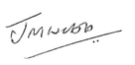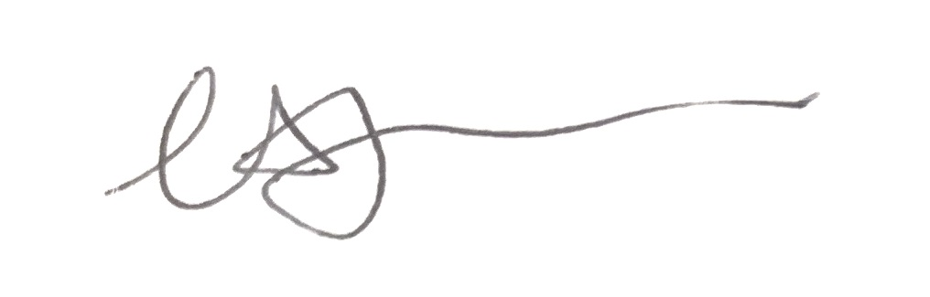

Jonathan Webb Elizabeth Jarvis
Headmaster Chair of Governors

